Aron Casiano

Professor Pavlov

CIS 171

December 13, 2019

Final Project

Business rules:

A School can sponsor one or more teams depending on the size of the school.

A team is sponsored by a school.

A team has a level.

A level has many teams.

A coach is qualified for one of more teams.

A team is qualified a coach.

A player is assigned to one or more teams depending on their age and weight.

A team is assigned one or players.

Logical data model:

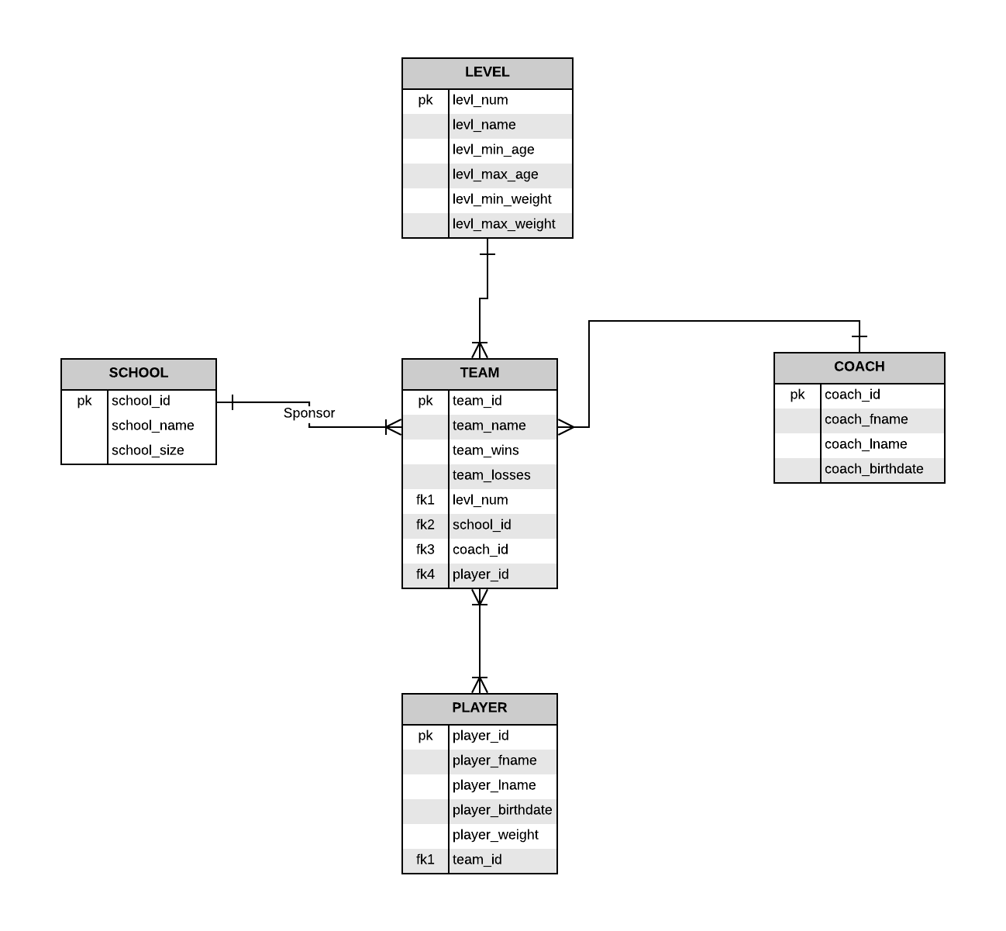

SQL statements:

What team do players belong in:

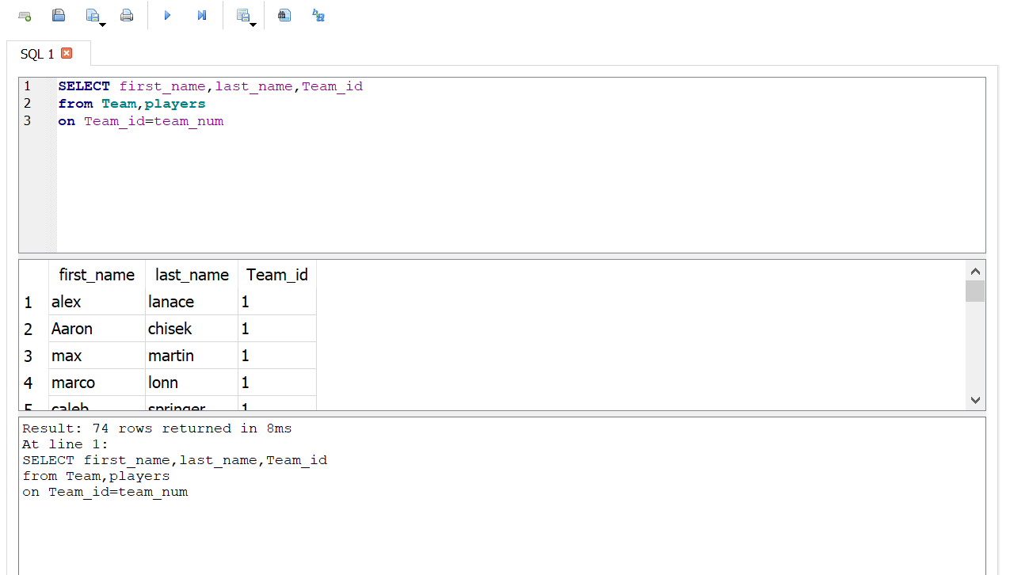

What level do coaches and team belong too.

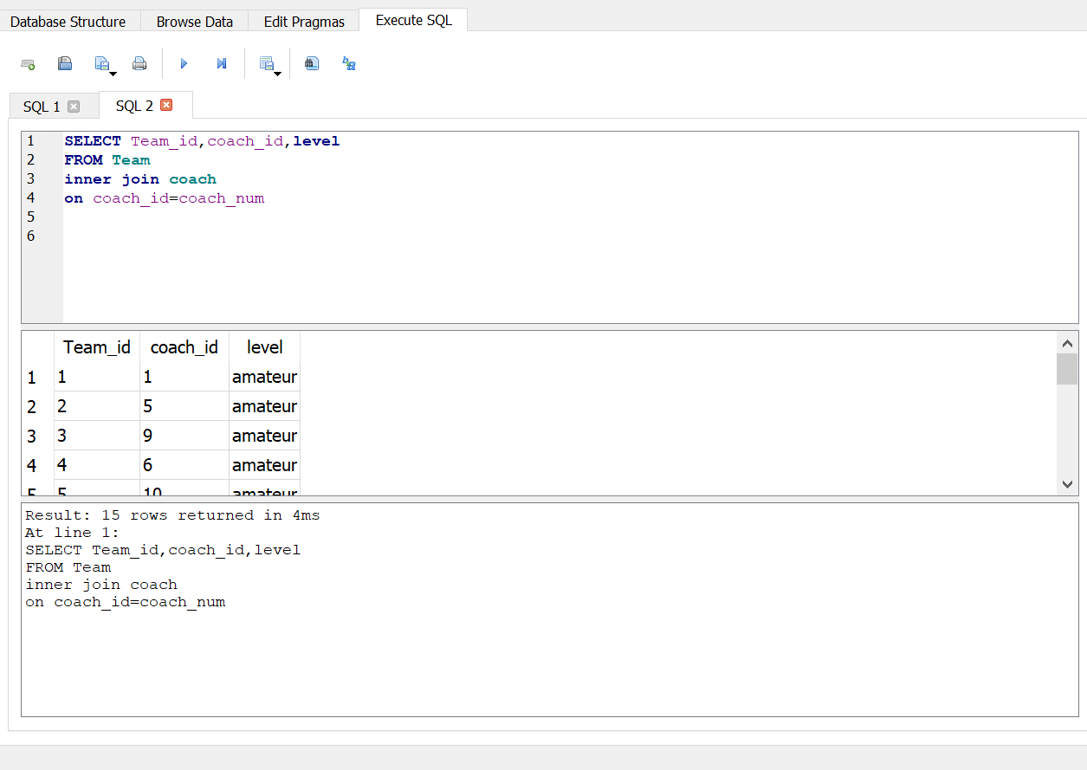

Who is sponsoring the team?: 